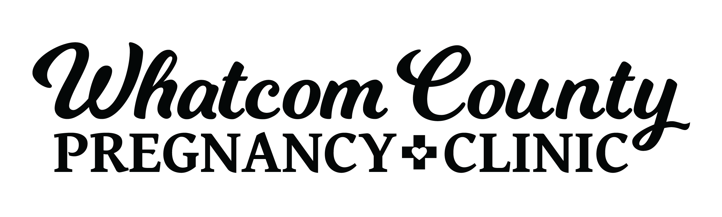
Earn While You Learn Application Form

In this program you will have the opportunity to learn about pregnancy and parenting skills. Parents participating in EWYL will meet once a week for one hour with a peer-mentor for lessons. Lessons are taught through videos and worksheets. Through participation ‘Baby Bucks’ (vouchers) can be earned to use in the Baby Shop. Items include new and gently used maternity clothes, baby clothes, blankets, diapers, wipes, and more. The prices of items are posted in the Shop and can be redeemed with ‘Baby Bucks’. The WCPC reserves the right for decisions of availability and pricing for all of our resources. The EWYL program is designed to meet the needs of parents who may feel the need for extra support in preparing for parenthood.

Contact Information

Name: ___________________________________________ Today’s Date: ______________

Your Date of Birth: ______________________ Age: ___________

Address: ________________________________________ City: _____________________ State: ________ Zip: ____________

Phone [primary] _________________________ □ Ok to leave voicemail □ Ok to text □ Ok to text weekly appointment reminders

E-mail address: ____________________________________ □ Ok to contact through e-mail

Help us get to know you better so we can best serve your needs…
Marital Status [please check one]
□ Married □ Separated □ Divorced □ Single □ Living Together □ Widowed

Living Situation [please check one]
□ Alone □ Boyfriend □ Husband □ Roommate(s) □ Parent(s) □ Family □ Other_______________________

Do you have other children? If so, what are their ages? __________________________________________________________________

Support System
Describe your support network:
___________________________________________________________________________________________
____________________________________________________________________________________________

Will a support person/partner/children be attending classes with you? □ No □ Yes If so, who? ________________

Concerns
What are your primary concerns regarding pregnancy and parenting?
_____________________________________________________________________________________________
_____________________________________________________________________________________________

Pregnancy Information
Are you pregnant at this time? □ No □ Yes If yes, what is your due date? _____________________________

See back side-→

Availability
Appointments are for one hour per week. It is our desire to work to the greatest ability to accommodate all client schedules. However, there are some circumstances in which we may not be able to accommodate all requests.
Note: The more flexible you are in your schedule, the sooner we will be able to start you in the Earn While You Learn program.

Please check all days and times that you are available.
Mornings □ Monday □ Tuesday □ Wednesday □ Thursday □ Friday
Afternoons □ Monday □ Tuesday □ Wednesday □ Thursday □ Friday

Program Goals
Please tell us what you hope to gain through participation in the Earn While You Learn program. Please also note specific goals you desire to achieve and any special topics you would like to learn about in regards to becoming the best parent you can be. ___________________________________________________________________________
____________________________________________________________________________________________________________________________________________________________________________________________________________________________________________________________________________________________________________________________________________________________________________________________________________________________________________________________________________________________

I agree that I will be solely responsible for inspecting and determining the fitness and safety of any material items I receive in connection with the Earn While You Learn program. I agree to hold harmless the WCPC and/or any of its employees and agents with respect to any and all claims of whatever nature arising out of my participation in the Earn While You Learn program and/or my receipt of any items in connection with such program. I understand that at any time my participation in the Earn While You Learn program may be revoked as deemed appropriate by clinic staff. I have read and understood the above information.

Signature of Recipient______________________________________________ Date_______________

Printed Name______________________________________________________

EWYL Coordinator Signature________________________________________ Date________________

FOR OFFICE USE ONLY

Class Information

Start Date __________________ Clinic Volunteer ________________________________

Notes/Special Insturctions____________________________________________________________________

__________________________________________________________________________________________

__________
__
_______________________________________________________________________________________

The Whatcom County Pregnancy Clinic (WCPC) is a nonprofit organization. All of our services are free to the client regardless of age, sex, race, income, nationality, religion, disability, marital status, or other arbitrary circumstances. Our clinic is faith based, but our faith is never imposed on the clients we serve.
07/2023

